# [***H&M sets goals to target biodiversity loss***](https://advance.lexis.com/api/document?collection=news&id=urn:contentItem:60VC-9BC1-F14X-V00B-00000-00&context=1516831)

just-style global news

September 15, 2020 Tuesday 10:28 AM GMT

Copyright 2020 Aroq Limited All Rights Reserved

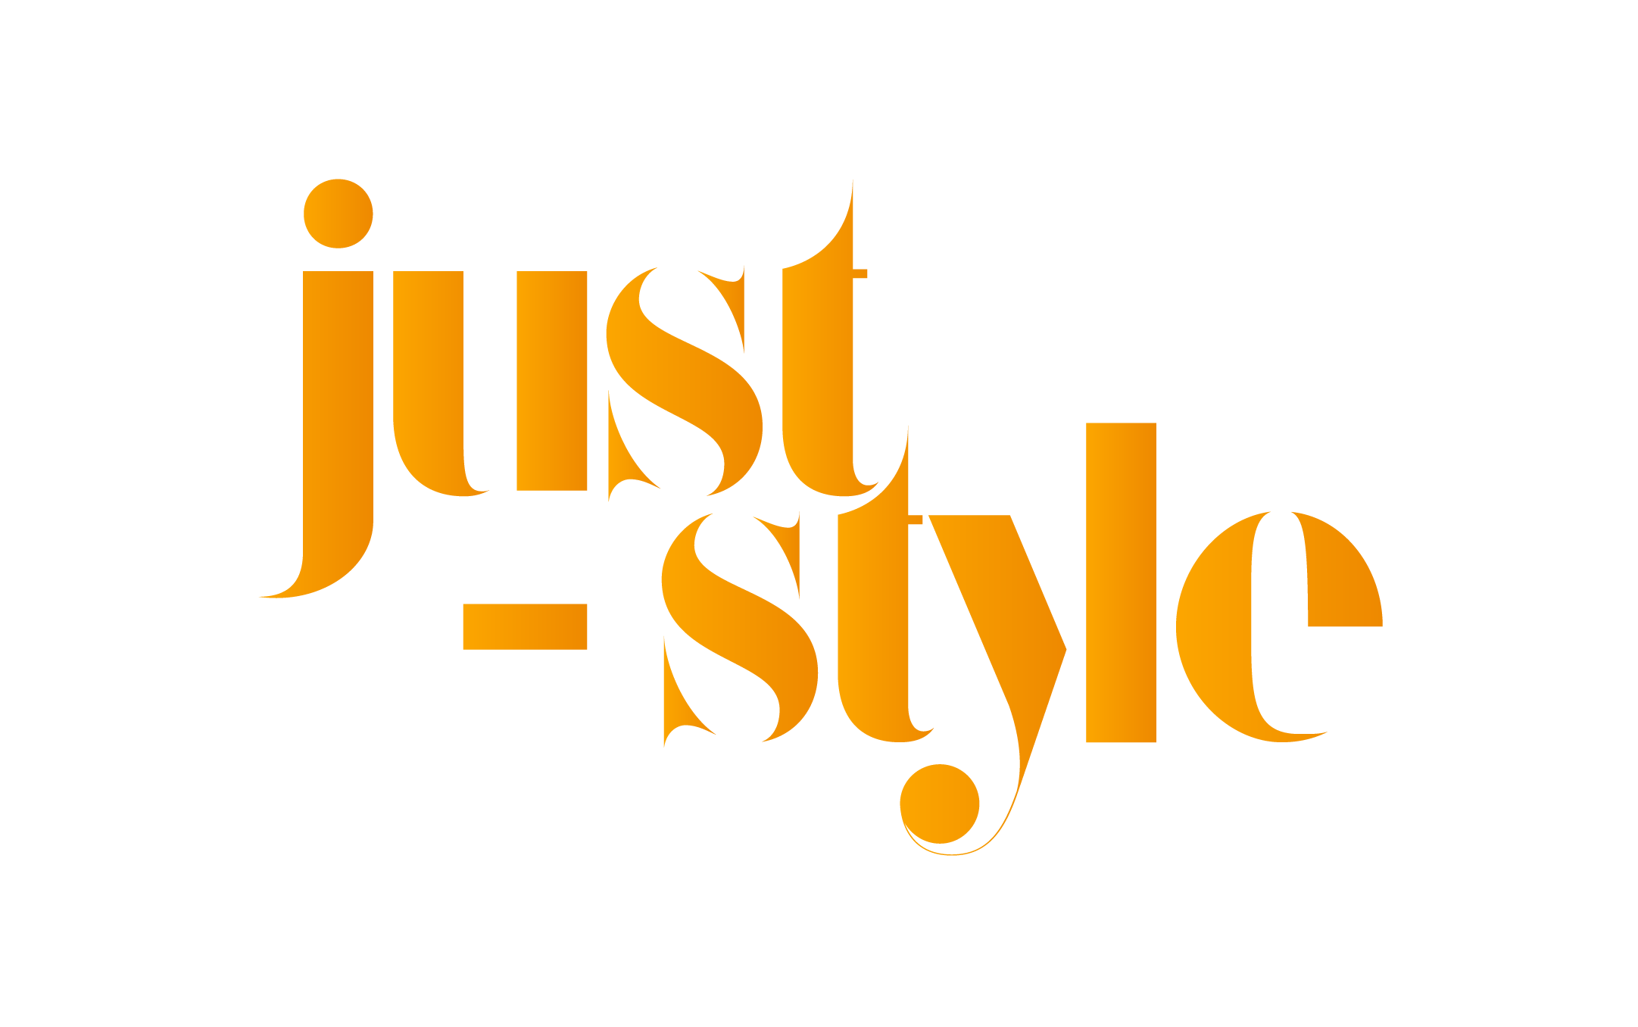

**Length:** 541 words

**Byline:** Hannah Abdulla

**Body**

Swedish fashion giant H&M Group has set two goals in a bid to fight ***biodiversity*** ***loss*** in line with the World Wildlife Fund (WWF) 'Living Planet Report', a comprehensive study of trends in global ***biodiversity*** and the health of the planet.

According to the report, "unsustainable human activity" is pushing the planet's natural systems that support life on Earth to the edge.

To have a net positive impact on ***biodiversity*** in the long-term, H&M Group says it means not only avoiding and mitigating harm, but leaving the natural environment in a better state than beforehand through habitat restoration and protection.

In order to achieve this, the group has set two objectives: to prevent and reduce the company's overall impact on ***biodiversity*** and natural ecosystems in its value chain; and help to protect and restore ***biodiversity*** and natural ecosystems in line with what science requires.

Science currently calls for action to ensure that 50% of the Earth's surface is protected, restored and sustainably managed by 2030, with 30% of the area being fully protected and 20% sustainably managed.

"When using the land for cultivating the cotton to make our customers' favourite garments, regenerative farming is the future. When washing and dyeing the customers favorite jeans the soil and water should be left unharmed. Our ambition for ***biodiversity***, together with our climate strategy, will help us in our work to relieve the planet from critical pressure, creating a more resilient supply chain and business," says Cecilia Brännsten, environmental sustainability manager, H&M Group.

The base for H&M Group's ambition on ***biodiversity*** started with a ***biodiversity*** footprint assessment to identify the biggest impact areas of its business. The next step is now to align and formalise goals.&nbsp;Looking ahead, the company will continue to:

cooperate with WWF through a specific ***biodiversity*** workstream, work on ***biodiversity*** traceability strategy to measure progress, participate in forums and cooperating with organisations driving work in the area of ***biodiversity***.

"It is extremely important that businesses start taking action to fight ***biodiversity*** ***loss***, as they have a powerful role to play in bending the curve and investing in nature," explains Erika Sundell, head of corporate partnerships at WWF Sweden. "We salute H&M's holistic approach to manage their impact and dependence on ***biodiversity*** and hope that other companies will follow their&nbsp;example.

A recent report published by McKinsey & Company suggested that not enough is being done to counter the impact of the apparel sector on ***biodiversity*** ***loss***.

According to '***Biodiversity***: The next frontier in sustainable fashion' , ***biodiversity*** is declining at a faster rate than ever before in human history, with the apparel industry a significant contributor to ***biodiversity*** ***loss***.

Apparel supply chains are directly linked to soil degradation, conversion of natural ecosystems, and waterway pollution.

Meanwhile, H&M said today (15 September) it&nbsp;expects to return to profit in the third quarter, with preliminary results showing the Swedish fashion giant's recovery from Covid-related store&nbsp;closures is better than anticipated thanks to more&nbsp;full-price sales and strong cost control.

**Classification**

**Language:** ENGLISH

**Publication-Type:** Web Publication

**Journal Code:** SID2

**Subject:** ***BIODIVERSITY*** (95%); ***BIODIVERSITY*** CONSERVATION (90%); ECOSYSTEMS & HABITATS (90%); ENVIRONMENTAL & WILDLIFE ORGANIZATIONS (90%); SUSTAINABLE DEVELOPMENT (90%); WILDLIFE CONSERVATION (90%); FASHION & ENVIRONMENT (89%); CONSERVATION (78%); ECOSYSTEM CONSERVATION (78%); ENVIRONMENT & NATURAL RESOURCES (78%); ENVIRONMENTALISM (78%); HABITAT CONSERVATION (78%); LIFE FORMS (78%); REGENERATIVE AGRICULTURE (78%); SOIL HEALTH (78%); SUSTAINABILITY (78%); SUSTAINABLE FASHION (78%); WILDLIFE (78%); TRENDS (77%); CORPORATE ENVIRONMENTAL RESPONSIBILITY (75%); LAND RECLAMATION (75%); SUSTAINABLE AGRICULTURE (75%); NATURAL RESOURCES MANAGEMENT (74%); ASSOCIATIONS & ORGANIZATIONS (73%); VALUE CHAIN (73%); ALLIANCES & PARTNERSHIPS (71%); LAND DEGRADATION (66%); H&M (%)

**Company:**  H&M HENNES & MAURITZ AB (92%)

**Ticker:** HM.B (STO) (92%)

**Industry:** NAICS448140 FAMILY CLOTHING STORES (92%); NAICS446120 COSMETICS, BEAUTY SUPPLIES & PERFUME STORES (92%); SUSTAINABLE DEVELOPMENT (90%); FASHION & ENVIRONMENT (89%); FASHION INDUSTRY (89%); FASHION & APPAREL (78%); REGENERATIVE AGRICULTURE (78%); SOIL HEALTH (78%); SUSTAINABLE FASHION (78%); SUSTAINABLE AGRICULTURE (75%); CANALS & WATERWAYS (74%)

**Geographic:** EARTH (92%); SWEDEN (79%)

**Load-Date:** September 15, 2020

**End of Document**